PROBLEM STATEMENT
DASHBOARD 1: SUMMARY
Key Performance Indicators (KPIs) Requirements:
- Total Loan Applications:
select count(id) as total_loan_application from bank_loans;

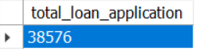

  - Month-to-Date (MTD) Loan Applications:
select month(issue_date) as month,count(id) as total_loan_application from bank_loans
where month(issue_date)=12 and year(issue_date)=2021 group by 1;

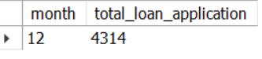

  - Previous-Month-to-Date (PMTD) Loan Applications:
select month(issue_date) as month,count(id) as total_loan_application from bank_loans
where month(issue_date)=11 and year(issue_date)=2021 group by 1;

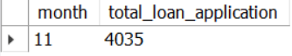

  - MoM Change % for total Loan Applications = ((MTD - PMTD) / PMTD) * 100:
with cte1 as
(select month(issue_date) as months,count(id) as total_loan_application from bank_loans
where year(issue_date)=2021 group by 1),
cte2 as
(select months, total_loan_application, lead(total_loan_application,1)
over(order by months desc) as total_loan_application_lead from cte1)

select round(((total_loan_application-total_loan_application_lead)/total_loan_application_lead)
*100,2) as MoM_change_percent from cte2 where months=12;

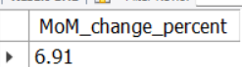

- Total Funded Amount:

select sum(loan_amount)as funded_amount from bank_loans;

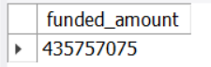

  - MTD Total Funded Amount:
select month(issue_date)as months, sum(loan_amount)as funded_amount from bank_loans
where month(issue_date)=12 and year(issue_date)=2021 group by month(issue_date);

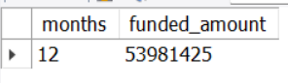

  - PMTD Total Funded Amount:

select month(issue_date)as months, sum(loan_amount)as funded_amount from bank_loans
where month(issue_date)=11 and year(issue_date)=2021 group by month(issue_date);

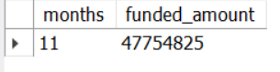
2.3 MoM Change % for total Funded Amount = ((MTD - PMTD) / PMTD) * 100:
with cte1 as
(select month(issue_date) as months,sum(loan_amount) as funded_amount from bank_loans
where year(issue_date)=2021 group by month(issue_date)),
cte2 as
(select months, funded_amount, lead(funded_amount,1)
over(order by months desc) as funded_amount_lead from cte1)

select round(((funded_amount-funded_amount_lead)/funded_amount_lead)
*100,2) as MoM_change_percent from cte2 where months=12;

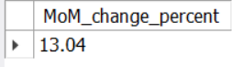
OR
((53981425-47754825)/47754825)*100=13.038

- Total Amount Received:
select sum(total_payment) as received_amount from bank_loans;

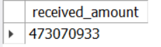
  - (MTD) Total Amount Received:
select month(issue_date)as months, sum(total_payment) as received_amount from bank_loans
where month(issue_date)=12 and year(issue_date)=2021 group by month(issue_date);

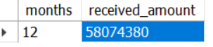
  - (PMTD) Total Amount Received:
select month(issue_date)as months, sum(total_payment) as received_amount from bank_loans
where month(issue_date)=11 and year(issue_date)=2021 group by month(issue_date);

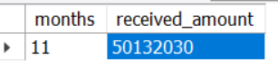
3.3 MoM Change % for total Amount Received = ((MTD - PMTD) / PMTD) * 100:
((58074380-50132030)/50132030)*100=15.84

4. Average Interest Rate:
select avg(int_rate) as avg_interest_rate from bank_loans;

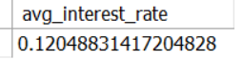

  - (MTD) Average Interest Rate:
select month(issue_date)as months, avg(int_rate) as avg_interest_rate from bank_loans
where month(issue_date)=12 and year(issue_date)=2021 group by month(issue_date);

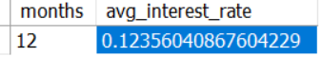
4.2 (PMTD) Average Interest Rate:
select month(issue_date)as months, avg(int_rate) as avg_interest_rate from bank_loans
where month(issue_date)=11 and year(issue_date)=2021 group by month(issue_date);

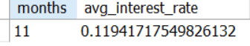
4.3 MoM Change % for Average Interest Rate = ((MTD - PMTD) / PMTD) * 100:
((0.1235-0.1194)/0.1194)*100=3.43

- Average Debt-to-Income Ratio (DTI):
select avg(dti) as avg_dti from bank_loans;

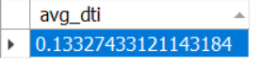
  - (MTD) Average Debt-to-Income Ratio (DTI):
select month(issue_date)as months, avg(dti) as avg_dti from bank_loans
where month(issue_date)=12 and year(issue_date)=2021 group by month(issue_date);

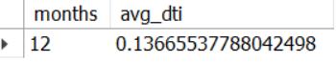
  - (PMTD) Average Debt-to-Income Ratio (DTI):
select month(issue_date)as months, avg(dti) as avg_dti from bank_loans
where month(issue_date)=11 and year(issue_date)=2021 group by month(issue_date);

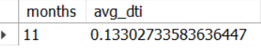

5.3 MoM Change % for Average Debt-to-Income Ratio (DTI) =
((MTD - PMTD) /PMTD)*100:
((0.1366-0.1330)/0.1330)*100=2.70

Good Loan v Bad Loan KPI’s

Good Loan:
Good Loan Application Percentage, Good Loan Applications, Good Loan Funded Amount, Good Loan Total Received Amount,
select loan_status, count(id) as good_loan_applications,
(count(id)/(select count(id) from bank_loans))*100 as good_loan_applications_perc,
sum(loan_amount) as good_Loan_Funded_Amount, sum(total_payment) as
good_Loan_Received_Amount from bank_loans
where loan_status in ("Fully Paid","Current") group by loan_status;

Bad Loan:
Bad Loan Applications, Bad Loan Application Percentage, Bad Loan Funded Amount, Bad Loan Total Received Amount,

select loan_status, count(id) as bad_loan_applications,
(count(id)/(select count(id) from bank_loans))*100 as bad_loan_applications_perc,
sum(loan_amount) as bad_Loan_Funded_Amount, sum(total_payment) as
bad_Loan_Received_Amount from bank_loans
where loan_status="Charged Off" group by loan_status;

Loan Status Grid View:
The report should include the following metrics for each loan status,
Total Loan Applications
Total Loan Applications percentage
Total Funded Amount
Total Amount Received
Average Interest Rate
Average Debt-to-Income Ratio (DTI)
select loan_status, count(id) as total_loan_applications,
(count(id)/(select count(id) from bank_loans))*100 as total_loan_applications_perc,
sum(loan_amount) as total_Funded_Amount, sum(total_payment) as
total_Received_Amount, round(avg(int_rate),3) as Average_Interest_Rate,
round(avg(dti),3) as Average_dti
from bank_loans group by loan_status;

Loan Status-MTD- Grid View:
The report should include the following metrics for each loan status,
Total Loan Applications
Total Loan Applications percentage
Total Funded Amount
Total Amount Received
Average Interest Rate
Average Debt-to-Income Ratio (DTI)
select loan_status, count(id) as total_loan_applications,
(count(id)/(select count(id) from bank_loans))*100 as total_loan_applications_perc,
sum(loan_amount) as total_Funded_Amount, sum(total_payment) as
total_Received_Amount, round(avg(int_rate),3) as Average_Interest_Rate,
round(avg(dti),3) as Average_dti from bank_loans
where month(issue_date)=12 and year(issue_date)=2021 group by loan_status;

The main metrics are Total Loan Applications, Total Funded Amount, and Total Amount Received,
Monthly Trends by Issue Date

select month(issue_date) as month_no, monthname(issue_date) as months, count(id) as
total_loan_applications, sum(loan_amount) as total_Funded_Amount, sum(total_payment) as
total_Received_Amount from bank_loans
where year(issue_date)=2021
group by month(issue_date), monthname(issue_date) order by month_no;

month_no | months | total_loan_applications | total_Funded_Amount | total_Received_Amount
1 | January | 2332 | 25031650 | 27578836
2 | February | 2279 | 24647825 | 27717745
3 | March | 2627 | 28875700 | 32264400
4 | April | 2755 | 29800800 | 32495533
5 | May | 2911 | 31738350 | 33750523
6 | June | 3184 | 34161475 | 36164533
7 | July | 3366 | 35813900 | 38827220
8 | August | 3441 | 38149600 | 42682218
9 | September | 3536 | 40907725 | 43983948
10 | October | 3796 | 44893800 | 49399567
11 | November | 4035 | 47754825 | 50132030
12 | December | 4314 | 53981425 | 58074380

Regional Analysis by State
select address_state, count(id) as total_loan_applications,
sum(loan_amount) as total_Funded_Amount, sum(total_payment) as total_Received_Amount
from bank_loans where year(issue_date)=2021 group by address_state;

address_state | total_loan_applications | total_Funded_Amount | total_Received_Amount
CA | 6894 | 78484125 | 83901234
NY | 3701 | 42077050 | 46108181
TX | 2664 | 31236650 | 34392715
CT | 730 | 8435575 | 9357612
MD | 1027 | 11911400 | 12985170
MA | 1310 | 15051000 | 16676279
MI | 685 | 7829900 | 8543660
KY | 320 | 3504100 | 3792530
MS | 19 | 139125 | 149342
KS | 260 | 2872325 | 3247394
GA | 1355 | 15480325 | 16728040
NC | 759 | 8787575 | 9534813
NJ | 1822 | 21657475 | 23425159
WA | 805 | 8855525 | 9531739
OH | 1188 | 12991375 | 14330148
AZ | 833 | 9206000 | 10041986
IL | 1486 | 17124225 | 18875941
CO | 770 | 8976000 | 9845810
WI | 446 | 5070450 | 5485161
FL | 2773 | 30046125 | 31601905
IN | 9 | 86225 | 85521
VA | 1375 | 15982650 | 17711443
ME | 3 | 9200 | 10808
NE | 5 | 31700 | 24542
NM | 183 | 1916775 | 2084485
MO | 660 | 7151175 | 7692732
UT | 252 | 2849225 | 2952412
LA | 426 | 4498900 | 5001160
SC | 464 | 5080475 | 5462458
AL | 432 | 4949225 | 5492272
TN | 17 | 162175 | 141522
NH | 161 | 1917900 | 2101386
SD | 63 | 606150 | 656514
DE | 110 | 1138100 | 1269136
WY | 79 | 890750 | 1046050
OR | 436 | 4720150 | 4966903
MN | 592 | 6302600 | 6750746
DC | 214 | 2652350 | 2921854
HI | 170 | 1850525 | 2080184
NV | 482 | 5307375 | 5451443
VT | 54 | 504100 | 534973
IA | 5 | 56450 | 64482
ID | 6 | 59750 | 65329
RI | 196 | 1883025 | 2001774
PA | 1482 | 15826525 | 17462908
AR | 236 | 2529700 | 2777875
OK | 293 | 3365725 | 3712649
AK | 78 | 1031800 | 1108570
MT | 79 | 829525 | 892047
WV | 167 | 1830525 | 1991936

Loan Term Analysis
select term, count(id) as total_loan_applications,
sum(loan_amount) as total_Funded_Amount, sum(total_payment) as total_Received_Amount
from bank_loans where year(issue_date)=2021 group by 1;

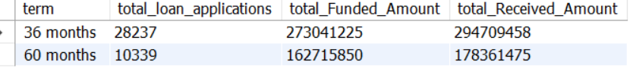

Employee Length Analysis
select emp_length, count(id) as total_loan_applications,
sum(loan_amount) as total_Funded_Amount, sum(total_payment) as total_Received_Amount
from bank_loans where year(issue_date)=2021 group by 1;

emp_length | total_loan_applications | total_Funded_Amount | total_Received_Amount
< 1 year | 4575 | 44210625 | 47545011
10+ years | 8870 | 116115950 | 125871616
6 years | 2228 | 25612650 | 27908658
3 years | 4088 | 43937850 | 47551832
1 year | 3229 | 32883125 | 35498348
5 years | 3273 | 36973625 | 40397571
9 years | 1255 | 15084225 | 16516173
2 years | 4382 | 44967975 | 49206961
4 years | 3428 | 37600375 | 40964850
8 years | 1476 | 17558950 | 19025777
7 years | 1772 | 20811725 | 22584136

Loan Purpose Breakdown
select purpose, count(id) as total_loan_applications,
sum(loan_amount) as total_Funded_Amount, sum(total_payment) as total_Received_Amount
from bank_loans where year(issue_date)=2021 group by 1;

purpose | total_loan_applications | total_Funded_Amount | total_Received_Amount
Debt consolidation | 18214 | 232459675 | 253801871
credit card | 4998 | 58885175 | 65214084
car | 1497 | 10223575 | 11324914
home improvement | 2876 | 33350775 | 36380930
small business | 1776 | 24123100 | 23814817
major purchase | 2110 | 17251600 | 18676927
moving | 559 | 3748125 | 3999899
other | 3824 | 31155750 | 33289676
house | 366 | 4824925 | 5185538
vacation | 352 | 1967950 | 2116738
educational | 315 | 2161650 | 2248380
wedding | 928 | 9225800 | 10266856
medical | 667 | 5533225 | 5851372
renewable_energy | 94 | 845750 | 898931

Home Ownership Analysis
select home_ownership, count(id) as total_loan_applications,
sum(loan_amount) as total_Funded_Amount, sum(total_payment) as total_Received_Amount
from bank_loans where year(issue_date)=2021 group by 1;

